Course Diagram Symbols

Use these symbols to build your own course diagrams, each one can be copied and pasted to create your clubs Sailing Instructions.

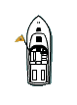

Change colours of symbols/buoys to suit marks as needed.
Black band can be placed over mark if required also.

3p
3s

Finish
Start

